

[Your Town/County]
Transportation Safety Action Plan

Adopted January 1, 2026


Table of Contents
Executive Summary 3
Section 1 – What is a Safety Action Plan? 4
1.1 – Introduction to Safety Action Plans 4
1.2 – Local Context & Plan Goals 4
Section 2 – Safety Action Plan Development 6
2.1 – Plan Development Process 6
2.2 – Safe System Approach 6
2.3 – Leadership and Oversight 8
Section 3 – Plan, Policy & Program Review 9
3.1 – State/Federal Programs 9
3.2 – Local Plans and Programs 10
3.3 – Recent and Proposed Near-term Improvement Projects 10
Section 4 – Safety Data Analysis 12
4.1 – What are the Primary Safety Problems in the Community? 12
4.2 – Where are the Primary Safety Problems in the Community? 13
4.3 – What Neighborhoods are Most Impacted by Crashes? 14
Section 5 – Public Engagement 15
5.1 – Engagement Process 15
5.2 – Engagement Results 15
Section 6 – Crash Reduction Framework/Strategies 16
6.1 – Goals, Strategies & Actions 16
6.2 – Proven Safety Countermeasures 17
6.3 – Priority Safety Project Locations 18
6.4 – Performance Measures 20
6.5 – Project Funding 20
Section 7 – Monitoring the Safety Action Plan 23
7.1 – Reporting Progress 23
7.2 – Statewide and Regional Coordination 23
Appendix: Template for Annual Reporting (20XX) 24

Acknowledgements
Thank you to everyone who participated in the development of this Transportation Safety Action Plan for the [Town of X]. By adopting and implementing this plan, the community is committing itself toward a safer future for its residents and visitors. Many people have been involved in the creation of this plan, but special thanks are given to the following individuals:

Steering Committee Members
Bob Jones
Bill Smith
Jill Johnson

Town Staff & Officials
Suzy James
Tom Cooper


Document developed using templates, data tools, and materials developed by the Central Pines Regional Council through their “Safe Streets for All in the Triangle” program.

Executive Summary
The [Your Town/County] Transportation Safety Action Plan is built upon a bold commitment by the community: [your community’s stated goal/target as defined in the plan]. Accomplishing this goal will require a fundamental shift in the community’s method of planning and designing transportation projects, developing local policies, and conducting education and enforcement campaigns through a “Safe System Approach” that prioritizes and balances the need for safer vehicles, safer speeds, safer road users, safer roads, and improved post-crash care.
Over the past five years, [X County] has had an average of X fatal and/or serious injury crashes each year.
The sections of this document that follow provide information on the background data, potential strategies, and potential prioritized first steps for improving transportation safety in [Your Town/County].
Section 1 – What is a Safety Action Plan?
This section provides an overview of what a Safety Action Plan is, and discusses the local context for the plan, including the number of crashes and statement of the community’s safety goal(s).
Section 2 – Safety Action Plan Development
This section describes the process of developing the Safety Action Plan and provides an overview of the “Safe System Approach.”
Section 3 – Plan, Policy & Program Review
This section provides an overview of state/federal safety planning programs and assesses existing local plans, policies, and projects for how they incorporate (or could incorporate) safety.
Section 4 – Safety Data Analysis
This section includes an analysis of fatal and serious injury crashes in the community, identification of the community’s “High Injury Network,” and analysis of crash demographic data.
Section 5 – Public Engagement
This section documents the public engagement process for the plan and summarizes the feedback received from both in-person and online engagement sources.
Section 6 – Crash Reduction Framework/Strategies
This section reiterates the community’s safety goal and discusses implementation steps toward reaching the goal, including a number of strategies and proven safety countermeasures.
Section 7 – Monitoring the Safety Action Plan
This section discusses a process for tracking the performance of the community at moving toward its safety goals over time.

Section 1 – What is a Safety Action Plan?
1.1 – Introduction to Safety Action Plans
This document is a comprehensive Safety Action Plan developed by [Town/County] to address concerns related to transportation safety. The plan identifies urgent safety problems in the community and develops strategies and projects aimed at reducing serious injury and fatal crashes on roadways in both the short-term and long-term. The plan is designed in alignment with state and national plans and initiatives including the North Carolina Department of Transportation’s Strategic Highway Safety Plan (SHSP) and Highway Safety Improvement Program (HSIP) and the U.S. Department of Transportation’s Safe Streets and Roads for All (SS4A) program. The plan is designed to be compliant with SS4A planning requirements so that the community can pursue future implementation funding through that program.
This plan is rooted in the principles of the “Safe System Approach,” which acknowledges that people will make mistakes but that those mistakes should not cost lives. By emphasizing safe roads, safe speeds, safe vehicles, safe users, and post-crash care, the plan sets a framework for reducing risks across the community’s transportation network. This proactive approach helps address unsafe conditions without waiting for the next crash to occur.
At its core, this plan is a roadmap that identifies high-priority corridors, effective countermeasures, and strategies for addressing safety in transportation planning, funding, and engineering. It is both a technical resource and a call to action, reinforcing the community’s commitment to protecting lives and fostering a community where all people can reach their destinations safely.
1.2 – Local Context & Plan Goals
Insert a paragraph or two here providing general context about the community – things such as location, size, growth conditions, major industries/employment, etc. You could also include a map or pictures of the community.
In [Town/County], between 20XX and 20XX there were a total of X,XXX roadway crashes of all types. Of these, X crashes resulted in fatalities and X crashes resulted in serious injuries. X people lost their lives as a result of crashes within the community during this period. The trend for crashes has been upward/downward/relatively flat over time during these five years, with the highest number of fatal and serious injury crashes (X) occurring in 20XX and the lowest number (X) occurring in 20XX. More specific data on crashes can be found in Section 4 of this document.
In an effort to address these roadway safety problems, the [Town/County Board Name] has adopted the following goal for this Transportation Safety Action Plan:
Type your goal here. It needs to include both a number component (number of reduced crashes, percent reduction in crash rate, etc.) and a time component (period of time over which the reduction will occur).
The recommendations included in this plan are intended to help the community reach this goal.

Section 2 – Safety Action Plan Development
2.1 – Plan Development Process
The safety planning process follows five primary steps:
Establishing Partners and Stakeholders
The first step involves establishing partners and stakeholders who participate in the process. For this plan, these partners and stakeholders include: [list of partners and stakeholders]. Add brief 1-2 sentence description of how the partners/stakeholders were engaged in the process.
Analyzing Safety Data and Stakeholder Inputs
The next step involves analyzing safety data and stakeholder inputs. For this plan, data analysis identifies crash types and trends as well as areas and populations most at risk of fatal and serious injury crashes. Areas are then spatially located within a defined “High Injury Network” (HIN). To ensure meaningful impacts on the local community, local and regional plans, policies and public input are also incorporated into decision making.
Determining Safety Problems
The analysis of safety conditions determines safety problems, focus crash types, and systemic safety risks.
Analyzing Crash Reduction Strategies
For the Action Plan, strategies are identified that help to mitigate crashes. Safety analysis and strategy development focus on priority crash risks, locations, and policy measures.
Implementing the Action Plan
Through adoption of this Action Plan, [Town/County Name] commences the fifth step in the safety planning process: implementing the plan. The plan outlines a Crash Reduction Framework with strategies, actions, project examples, and potential policies to reduce fatalities and serious injuries across the region. The identified actions align with potential funding opportunities. [Town/County Name] will regularly evaluate the Action Plan with a focused review of adopted safety targets and performance measures and will update the plan as needed.
2.2 – Safe System Approach
An emerging initiative in transportation planning is the adoption and implementation of Safe System Approach (SSA) principles. The SSA is a holistic, proven methodology adopted by the U.S. Department of Transportation as a guiding model to improve roadway safety. The SSA provides a comprehensive framework to address and mitigate safety risks in transportation systems. The approach is based on six guiding principles:
- Death and serious injuries are unacceptable – although all crashes are inconvenient, our focus should be on crashes that result in death or serious harm.
- Humans make mistakes – even the best drivers will make mistakes that can lead to a crash, but we can design our system in a way that minimizes the life-altering impacts of a mistake.
- Humans are vulnerable – the human body can only withstand so much impact from a crash.
- Responsibility is shared – safety depends on action from every part of the transportation system, from elected leaders to project/program implementers to roadway users.
- Safety is proactive – transportation agencies should seek to proactively identify and address dangerous situations.
- Redundancy is critical – multiple layers of protection are needed so that if one aspect of the system fails to prevent a crash, other measures are in place to still keep people safe.
The SSA principles introduce a paradigm shift in roadway safety, transitioning from a reactive approach (implementing improvements after crashes occur) to a proactive approach that anticipates human error. This approach is designed to minimize opportunities for mistakes resulting in a fatality or serious injury. The SSA acknowledges that responsibility is shared among stakeholders and includes the following five elements of a Safe System:

Safer People
Promote safe and responsible driving habits among road users while prioritizing conditions that ensure their safe arrival at destinations.
Safer Vehicles
Increase the number of vehicle systems and features that prevent crashes and reduce the impact on people inside and outside the vehicle.
Safer Speeds
Encourage safer driving speeds on all roadways by using a combination of smart road design, setting speed limits, educating drivers, spreading awareness, and enforcing rules.
Safer Roads
Design roads that help reduce human errors and consider injury tolerances. This encourages safer behavior and facilitates easier travel for the most vulnerable people.
Post-Crash Care
Enhance crash survivability through access to medical care, keep first responders safe, and prevent secondary crashes through traffic incident management practices.
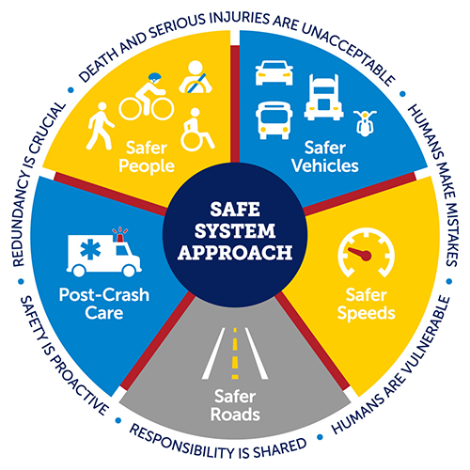

2.3 – Leadership and Oversight
This section should provide a brief (1-3 paragraph) overview of the process your community used to provide leadership and oversight to the plan development. In most communities, there will be some kind of committee (that could be composed of elected officials, staff, citizens, community organization representatives, etc.) that meets at least a few times to provide high-level direction to the process (such as drafting the goals, approving the public engagement approach, and reviewing the recommendations). There will also typically be staff-level engagement with local staff from departments such as planning, transportation/transit, engineering, public safety, and management/administration. You should provide a high-level summary of this engagement, the meetings held, and the input received.

Section 3 – Plan, Policy & Program Review
In safety planning, a plan, program and policy review identifies opportunities for consistency and collaboration in improving transportation safety at the statewide, regional, and local levels.
3.1 – State/Federal Programs
Highway Safety Improvement Program (HSIP)
The Highway Safety Improvement Program (HSIP) is a federal-aid program aimed at significantly reducing traffic fatalities and serious injuries on all public roads, including non-state-owned roads. In North Carolina, NCDOT’s Traffic Safety Unit administers the HSIP to improve highway safety on all public roads using a data-driven strategic approach. There are three core programs that fall under HSIP: the Strategic Highway Safety Plan (SHSP) described below, the state HSIP list of funded highway safety improvement projects, and the Railway-Highway Crossing Program (RHCP).
NCDOT has implemented several HSIP safety projects in [Town/County Name] in recent years, including: [list of projects].
Strategic Highway Safety Plan (SHSP)
The Strategic Highway Safety Plan (SHSP) is part of the HSIP. NCDOT receives HSIP funding for the Federal Highway Administration to develop programs and projects to improve safety on its roadways and is required to submit an annual report summarizing the NCDOT’s implementation and effectiveness of its HSIP. NCDOT’s program emphasizes three areas: Roadway Departure, Intersections, and Pedestrian and Bicycle Safety. NCDOT updated the SHSP in 2024 with active participation and contributions from stakeholders representing diverse safety needs, populations, and geographies across North Carolina. The SHSP serves as a linkage between local and federal planning through safety plans, such as this one. The [Your Town/County] Transportation Safety Action Plan is designed to align with the goals, vision, priorities, and solutions outlined in the SHSP.
Highway Safety Program (HSP)
The Governor’s Highway Safety Program (GHSP) and the National Highway Traffic Safety Administration (NHTSA) develop the Highway Safety Program (HSP). The HSP evaluates performance measures, analyzes current traffic safety conditions, outlines public engagement efforts and countermeasures, and details projects that GHSP plans to fund for a three-year cycle. Each three-year HSP identifies priority crash types and behaviors to address. Information about current grants and initiatives can be found on the North Carolina GHSP website.

3.2 – Local Plans and Programs
Local plan and policy review considers the extent to which existing plans, programs, and policies in [Town/County Name] address the elements of a Safe System and include recommendations or projects that incorporate proven safety countermeasures. In reviewing local plans and programs, it may be useful to consider the following questions based on the Safe System Approach:
- Does the plan/policy address the safety of multimodal road users (pedestrians, bicyclists, transit users, micromobility users, and users of mobility assistance devices)?
- Does the plan/policy address road user behavior?
- Does the plan/policy address the safety effects of vehicle design?
- Does the plan/policy address heavy vehicles (trucks)?
- Does the plan/policy address the safety effects of vehicle operating speed?
- Does the plan/policy address the safety effects of roadway design?
- Does the plan/policy address strategies for separating different road users?
- Does the plan/policy address intersection design?
- Does the plan/policy address how land use context affects roadway design?
- Does the plan/policy address post-crash care or emergency response?
- Does the plan/policy focus on crash severity?
- Does the plan/policy promote proactive safety solutions (as opposed to reactive)?
An analysis of key local plans and policies follows.
Local Plan/Policy Name
Description of plan/policy and assessment of how it addresses (or doesn’t, but should address) safety.
Local Plan/Policy Name
Description of plan/policy and assessment of how it addresses (or doesn’t, but should address) safety.
Local Plan/Policy Name
Description of plan/policy and assessment of how it addresses (or doesn’t, but should address) safety.
Local Plan/Policy Name
Description of plan/policy and assessment of how it addresses (or doesn’t, but should address) safety.
3.3 – Recent and Proposed Near-term Improvement Projects
Several major transportation projects are expected to be finished or to begin construction over the next few years in [Town/County Name]. Many of these projects include design measures that are intended to improve safety. The following projects are identified as under design or construction at this time:
Project | Description | Estimated Date
Main Street (TIP # R-5000) | Add median and sidewalks from 1st Street to 10th Street | 2028
Highway 100 (TIP # U-3000) | Modernize roadway from Tree Road to Creek Road | 2030
Sidewalk Curb Ramps | Town-funded project to improve curb ramps at 10 intersections | 2026

Section 4 – Safety Data Analysis
The NCDOT maintains data on the locations of all police-reported crashes in the state, and makes this data available on an annual basis. The most-recent available five-year data period (20XX through 20XX) was used to conduct the safety data analysis for this plan.
Crash data alone will not tell the full story of what is happening in a community, but it is an important component of the planning process, especially when then combined with input received from the community. The data can provide us with information about the key characteristics and behaviors that are leading to severe crashes in [Town/County Name], and the locations within the community where the most severe crashes are occurring.
4.1 – What are the Primary Safety Problems in the Community?
In [Town/County Name] there were X,XXX total people involved in crashes between 20XX and 20XX. Of these, XXX people were killed and XXX people were seriously injured. The figures below report these numbers by year.
All People Involved in Crashes in [Town/County] (2020-2024)

Fatalities & Serious Injuries from Crashes in [Town/County] (2020-2024)

The map below shows the locations of fatal and serious injury crashes in the community between 20XX and 20XX.
Map of Fatal and Serious Injury Crashes in [City/County Name], 20XX-20XX
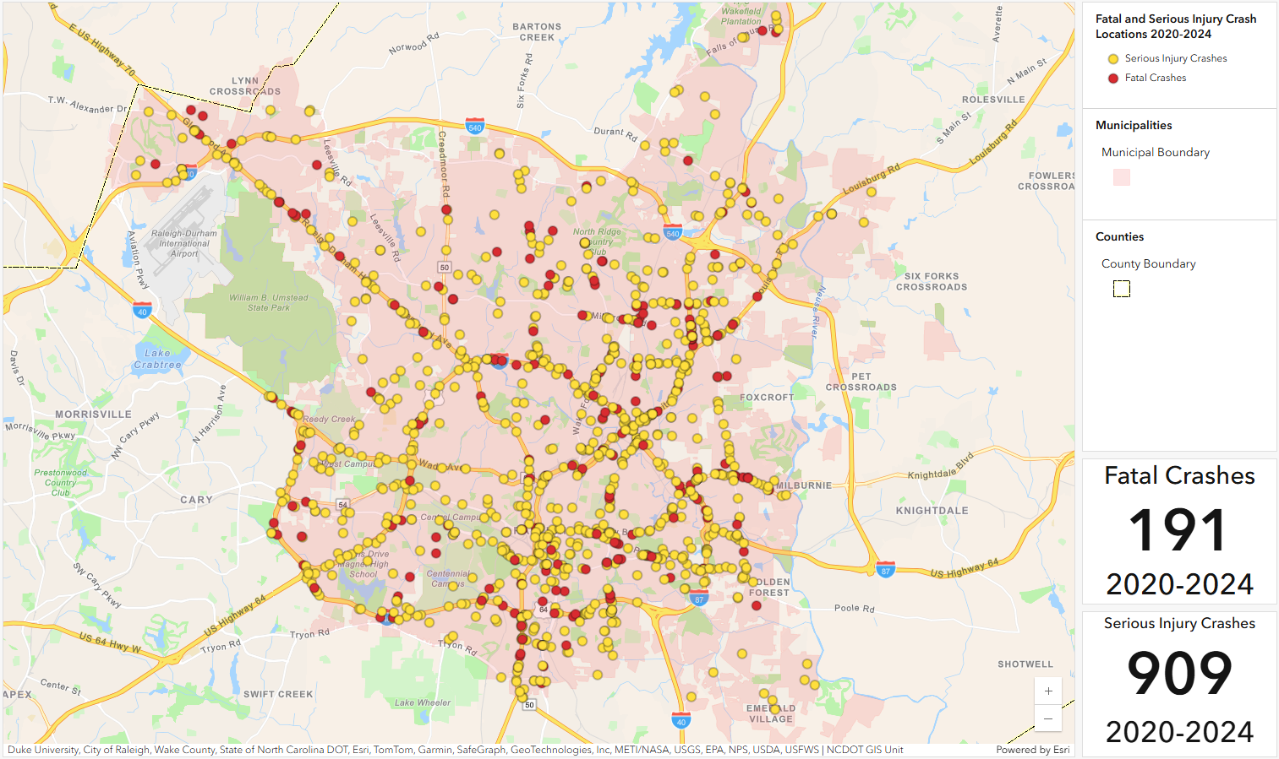
It can be useful to consider the types of crashes that are leading to fatal and serious injury outcomes in the community. The data indicates that the following crash type categories are most correlated with fatal and serious injury crashes in [Town/County Name], when compared against data for all crashes in the community:
Crash Characteristic | Fatal & Serious Injury Crash % | Total Crash % | Difference
Alcohol (All Persons) | 36% | 3% | +33%
Erratic, Reckless, Careless, Negligent or Aggressive Driving | 21% | 1% | +20%
Alcohol (Drivers) | 21% | 2% | +19%
Head-on Collision | 18% | 1% | +17%
Two-way Divided Road with unprotected median (center turn lane) | 39% | 23% | +16%
Motorcycle | 14% | 1% | +13%
Pedestrian | 11% | <0.5% | +11%
No Traffic Control Present | 64% | 54% | +10%
Lane Departure | 29% | 19% | +10%
Unbelted | 11% | 1% | +10%
Data based on NC Vision Zero safety dashboard for years 20XX-20XX.
This can be a good location for a discussion of any known local conditions/issues related to the above (for example, if the town knows that there is a certain road with a history of a certain crash type).
4.2 – Where are the Primary Safety Problems in the Community?
After identifying the types of crashes that account for the most significant safety problems in [Town/County Name], it is important to understand where those safety problems are occurring most often. This process involves analyzing crash location data to create a High Injury Network.
A High Injury Network (HIN) uses historic crash data to identify the road segments with the highest frequency of crashes resulting in a fatality or serious injury. This plan was developed using a tool prepared by Central Pines Regional Council that calculates fatal and serious injury crash rates on road segments (ratio of crashes to roadway usage) and the per-mile density of fatal and serious injury crashes on roadways, and identifies the corridors with the highest rates/densities. Generally speaking, these are the corridors that are most important on which to focus future safety improvements.
Map of High Injury Network in [Town/County], 20XX-20XX
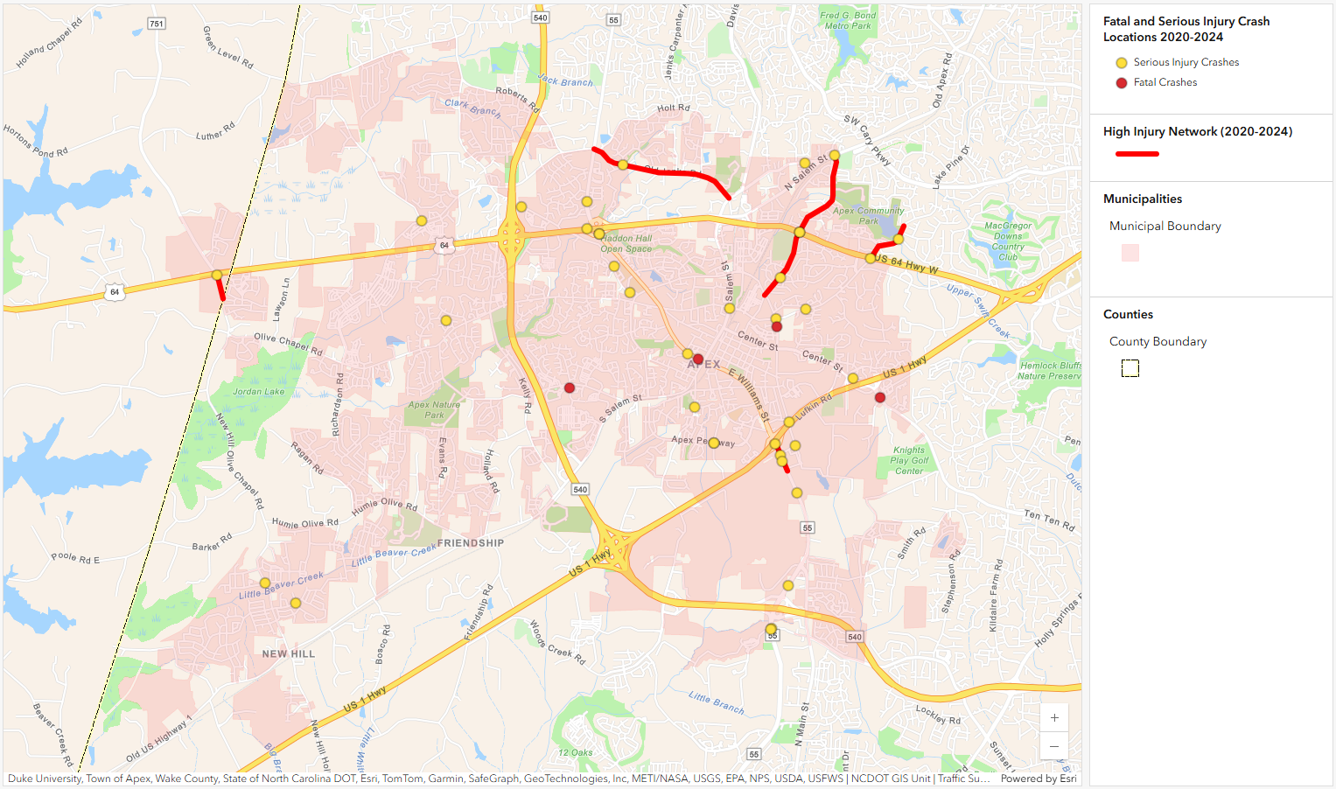
In addition to the overall High Injury Network, it is also helpful to look specifically at highly-vulnerable road users such as bicyclists and pedestrians to see if there are any patterns in crash data for these types of road users. The map below shows locations of bicycle and pedestrian-related crashes in the community.
Map of Non-motorized Crashes in [Town/County], 20XX-20XX
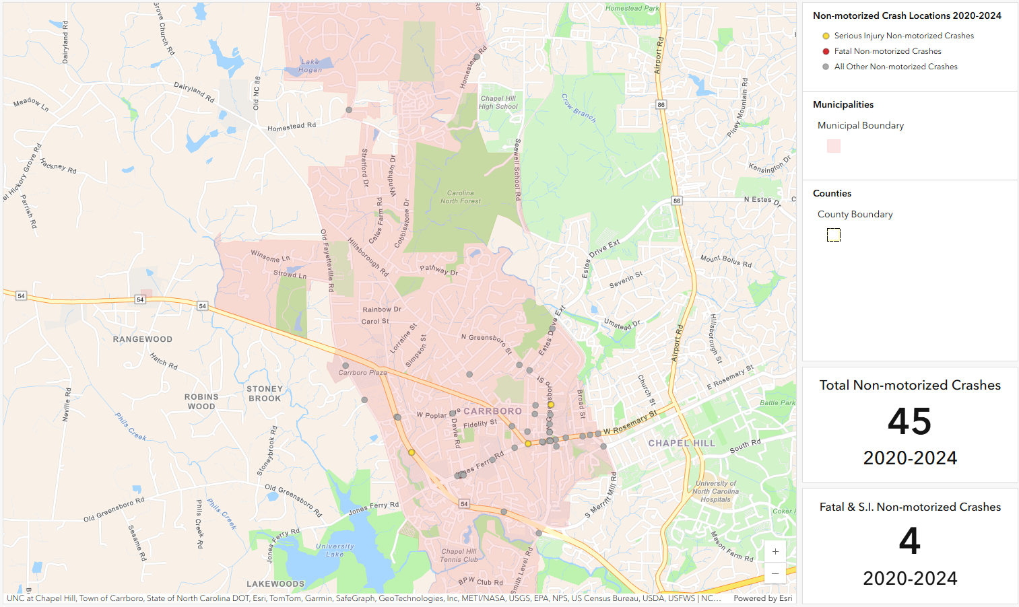
If there are any discernable patterns in the bike/ped crash map, you can discuss them here.
4.3 – What Neighborhoods are Most Impacted by Crashes?
It can also be helpful to look at the locations of crashes and the High Injury Network as compared to demographic data on the surrounding neighborhoods to see if there are any patterns associated with this. This plan uses a measure created by NCDOT called the Transportation Disadvantage Index that considers a number of demographic and income factors based on census data to identify areas where greater numbers of residents might have difficulty accessing transportation (have higher “transportation disadvantage”). The map below shows the High Injury Network (HIN) layer overlaid on the Transportation Disadvantage Index (TDI) layer, with higher TDI values indicating areas with more residents who are likely to have difficulty accessing transportation.

Map of Crash Locations in Relation to Transportation Disadvantaged Areas
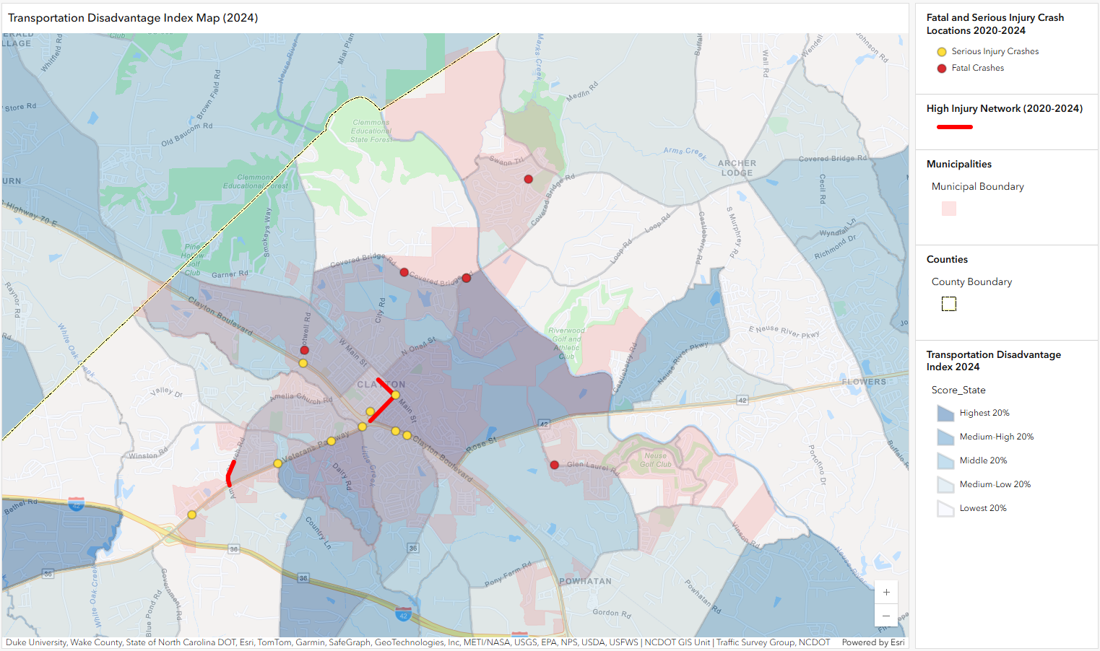
Use this paragraph to discuss any patterns (if any) between the HIN and the TDI. For example, if a large portion of your HIN falls within high-TDI neighborhoods you may want to cross-check against bike/ped crashes to see if more investments in bike/ped safety improvements might be merited in those areas due to higher bike/ped activity.

Section 5 – Public Engagement
5.1 – Engagement Process
Public engagement is a critical piece of any public planning effort. In the development of this plan, [Town/County] conducted the following engagement activities:
Pop-up Events
[Town] had tables at two Farmers Markets in July 2023 and at the Evening Park Concert in August 2023. At these events, we gathered input on the priorities of the community and used this information to aid in goal formation.
In December 2023, [Town] held additional pop-up tabling events at the Christmas Parade and the Fire Station Open House, where input was gathered on the draft plan recommendations.
Surveys
An online survey was available from May 2023 through August 2023 to gather input on the safety-related goals and priorities of the community, and to get information on the community’s safety concerns. A paper version of this survey was also available and was distributed through the library.
Open House
[Town] held an all-day open house at City Hall on November 15, 2023 where citizens could come in to discuss the plan with town staff, ask questions, and provide additional input.
5.2 – Engagement Results
You will need to write up a summary of results for your engagement process. Typical things to highlight include: number of participants, demographic info on participants, survey question responses, summaries of input from in-person events, and graphs, pictures, etc. It is also good to discuss how the input got used in the development of the plan.

Section 6 – Crash Reduction Framework/Strategies
The cornerstone of a Safety Action Plan is the Crash Reduction Framework – this identifies overarching safety goals for the community and supporting strategies and actions to address the safety problems identified through data analysis, public engagement, and unique local characteristics. The strategies are consistent with the Safe System Approach, and are prioritized in terms of implementation timeline. The Crash Reduction Framework is the roadmap for [Town/County Name]’s goal to [insert the town/county’s overall goal from Section 1 here].
6.1 – Goals, Strategies & Actions
The Action Plan has an overarching goal that creates a vision for how quickly and aggressively community leaders intend to reduce fatalities and serious injuries on roadways. The overarching safety goal is guided by a vision of moving toward a future with zero fatal and serious injury road crashes.
Overarching Safety Goal: Insert the overarching goal from Section 1 here.
The Safe System Approach is driven by the principle that fatalities and serious injuries on roadways are unacceptable. This Safety Action Plan supports this overall goal through the Crash Reduction Framework that identifies strategies and actions that will drive progress forward on reducing fatal and serious injury crashes.
- Strategies: represent a category of work to support the community’s safety aspirations
- Actions: outline the work the community and its partners will collaborate on to implement the Safety Action Plan
- Priority: represents the timeline for implementation (near-term/0-5 years, mid-term/5-10 years, or long-term/10-15 years)
Strategy | Action | Priority
Plan and design for safe speeds | Develop and adopt a road diet policy to guide the removal of excess roadway capacity and implementation of traffic calming countermeasures to eliminate unsafe speeding | Near-term
Plan and design for safe speeds | Reduce the standard speed limit to 25 MPH on existing and future neighborhood streets | Near-term
Assess and update internal practices and policies | Integrate the HIN into project and development reviews | Near-term
Assess and update internal practices and policies | Adopt a formal Complete Streets Policy and related design standards | Mid-term
Assess and update internal practices and policies | Support DUI/DWI court programs that focus on education and treatment over punishment | Long-term

It should be noted that much of the work envisioned in this plan cannot be carried out by [Town/County Name] alone, and that a number of other partner agencies and organizations will play important roles:
- [Town/County Name] – will lead actions involving local coordination, including transportation planning activities and discretionary funding programs of the Town such as Capital Improvement Plans (CIPs), maintenance projects, and local plans and studies, as well as pursuit of grants and the enforcement of traffic laws
- NCDOT – will lead actions requiring coordination with the Traffic Safety Unit, such as conducting Road Safety Audits on state-system roads, pairing funds with the HSIP for project implementation, and setting annual statewide safety targets, and will have primary responsibility for approving and implementing projects on roads that it maintains
- [MPO or RPO Name] – will serve as a resource for the community and ensure coordination of activities with regional plans and the plans of neighboring communities, and serve as a conduit for submitting projects into the STIP
- Other partners may include business or community organizations, non-profit organizations, and neighborhood or community organizations
6.2 – Proven Safety Countermeasures
There are many tools and resources that can improve transportation safety. As an industry best practice, the FHWA Proven Safety Countermeasures Initiative is a collection of specific roadway design or operational changes (countermeasures) that have been proven nationally to decrease roadway fatalities and serious injuries. FHWA maintains an online tool that recommends potential countermeasures based on roadway characteristics such as its land use context, expected volumes, crash history, and more to help communities across the country improve roadway safety.
Addressing roadway safety in [Town/County Name] will require the deployment of proven safety countermeasures across the community’s transportation network, starting with the High Injury Network. The right countermeasure, or mix of countermeasures, will vary based on the existing roadway conditions, safety issues, and the community’s vision for the future. Selection of safety countermeasures should be determined through the lens of the Safe System Approach, so that if a crash occurs it will not result in a fatality or serious injury. FHWA’s Proven Safety Countermeasures are listed below, grouped by the type of crashes they are intended to address, with links to more detailed information on each one.

Speed Management | Pedestrian & Bicyclist | Roadway Departure | Intersections | Crosscutting
Appropriate Speed Limits for All Road Users  Speed Safety Cameras  Variable Speed Limits | Bicycle Lanes  Crosswalk Visibility Enhancements  Leading Pedestrian Interval  Medians and Pedestrian Refuge Islands in Urban and Suburban Areas  Pedestrian Hybrid Beacons  Rectangular Rapid Flashing Beacons  Road Diets (Roadway Reconfiguration)  Walkways | Enhanced Delineation for Horizontal Curves  Longitudinal Rumble Strips and Stripes on Two-lane Roads  Median Barriers  Roadside Design Improvements at Curves  SafetyEdge  Wider Edge Lines | Backplates with Retroreflective Borders  Corridor Access Management  Dedicated Left- and Right-Turn Lanes at Intersections  Reduced Left-Turn Conflict Intersections  Roundabouts  Systemic Application of Multiple Low-Cost Countermeasures at Stop-Controlled Intersections  Yellow Change Intervals | Lighting  Local Road Safety Plans  Pavement Friction Management  Road Safety Audit

In addition to the FHWA countermeasures listed above, the North Carolina Department of Transportation has also developed its own glossary of safety countermeasures, most recently updated in 2025. This resource provides a user-friendly guide for identifying the most effective treatments and interventions based on specific road safety challenges. This is an additional resource the community can use to identify measures for improving safety and reducing fatal and serious injury crashes.
This is a good place to describe any particular countermeasures that you want to highlight for your community based on the data analysis in Section 4. For example, something like “Head-on crashes were highlighted in Section 4 as a problem for our community, so as a result we should pay special attention to countermeasures that may address this such as median barriers and longitudinal rumble strips.” You should make this section relevant to the data from your community.
6.3 – Priority Safety Project Locations
Priority locations for safety review focus on geographic locations within the community along the HIN. These locations are filtered through data review, local staff review, and public and stakeholder input to prioritize corridors/locations that are not currently scheduled for improvements through other scheduled/funded projects. These priority locations should be targeted for safety review and programming within the near term of the Safety Action Plan. Information on each of these priority locations can be found below.
NC 54 (Chapel Hill Road) from Aviation Pkwy to McCrimmon Pkwy
Road Characteristics |  | Crash Characteristics
Lanes | 2-3 | Fatal Crashes | 1
Median | No | Serious Injury Crashes | 0
Daily Traffic | 12,000-22,000 | Fatal/Serious Injury Crashes per Thousand VMT | 1.0
Posted Speed Limit | 45 MPH | Existing Plans
Sidewalks | Yes, Intermittent | Planned widening project north of this location (U-5750), but northing on this portion.
Crosswalks | No
Bike Facilities | No
Transit | No
Land Use | Mixed Commercial & Industrial
Recommended Safety Countermeasures
- Implement signal, signage and visibility improvements
- Add sidewalk or multi-use path on east side of road from Sunset Ave to Aviation Pkwy
- Add pedestrian crossing at Johnnie Robertson Dr, controlled by PHB or RRFB
- Evaluate access management strategies
- Evaluate lighting
- Install advisory speed signage

NC 54 (Chapel Hill Road) from Aviation Pkwy to McCrimmon Pkwy
Road Characteristics |  | Crash Characteristics
Lanes | 2-3 | Fatal Crashes | 1
Median | No | Serious Injury Crashes | 0
Daily Traffic | 12,000-22,000 | Fatal/Serious Injury Crashes per Thousand VMT | 1.0
Posted Speed Limit | 45 MPH | Existing Plans
Sidewalks | Yes, Intermittent | Planned widening project north of this location (U-5750), but northing on this portion.
Crosswalks | No
Bike Facilities | No
Transit | No
Land Use | Mixed Commercial & Industrial
Recommended Safety Countermeasures
- Implement signal, signage and visibility improvements
- Add sidewalk or multi-use path on east side of road from Sunset Ave to Aviation Pkwy
- Add pedestrian crossing at Johnnie Robertson Dr, controlled by PHB or RRFB
- Evaluate access management strategies
- Evaluate lighting
- Install advisory speed signage

NC 54 (Chapel Hill Road) from Aviation Pkwy to McCrimmon Pkwy
Road Characteristics |  | Crash Characteristics
Lanes | 2-3 | Fatal Crashes | 1
Median | No | Serious Injury Crashes | 0
Daily Traffic | 12,000-22,000 | Fatal/Serious Injury Crashes per Thousand VMT | 1.0
Posted Speed Limit | 45 MPH | Existing Plans
Sidewalks | Yes, Intermittent | Planned widening project north of this location (U-5750), but northing on this portion.
Crosswalks | No
Bike Facilities | No
Transit | No
Land Use | Mixed Commercial & Industrial
Recommended Safety Countermeasures
- Implement signal, signage and visibility improvements
- Add sidewalk or multi-use path on east side of road from Sunset Ave to Aviation Pkwy
- Add pedestrian crossing at Johnnie Robertson Dr, controlled by PHB or RRFB
- Evaluate access management strategies
- Evaluate lighting
- Install advisory speed signage

6.4 – Performance Measures
Performance measures serve as indicators of progress for each of the strategies identified in this Action Plan. Performance measures are required in comprehensive safety action plans and include measures of outputs (e.g. levels of activity) and outcomes (e.g. levels of effectiveness). Outputs reflect specific actions, projects, or improvements, whereas outcomes reflect the reduction in fatal and serious injury crashes. See Section 7 for more information on reporting performance measures.
6.5 – Project Funding
Federal Programs
The USDOT and NCDOT manage several funding programs to support local transportation safety projects. The USDOT FHWA provides core federal-aid funding to NCDOT specifically for safety and other transportation improvements. NCDOT programs most of these core federal funds through its Strategic Transportation Investments (STI) process, also known as SPOT. The SPOT ranking system evaluates safety alongside other scoring criteria. Additionally, USDOT offers the Safe Streets and Roads for All (SS4A) grant program to help local and Tribal transportation agencies develop and construct infrastructure safety projects. Partners should consider these federal funding sources valuable resources for project implementation.
SS4A Implementation Grants
Implementation grants are one of two grant types available under the SS4A program. Implementation grants provide federal funds to implement projects and strategies identified in a comprehensive safety action plan to address a roadway safety problem. Applicants must have an eligible action plan to apply for an implementation grant. All applications must address safety problems by proposing to implement projects and strategies (e.g. construction) included in the action plan within five years of executing a grant agreement. Eligible projects and strategies can include infrastructural, behavioral, or operational activities. The program is very competitive - in 2024, only about 20% of applications for implementation grant funds were awarded.
NCDOT Highway Safety Improvement Program (HSIP)
HSIP serves as a core federal-aid program dedicated to implementing safety projects through a data-driven process. NCDOT manages the HSIP to identify and address specific traffic safety concerns statewide. North Carolina’s HSIP focuses on reducing traffic crashes, injuries, and fatalities by targeting potentially hazardous locations. Using a comprehensive, data-driven methodology, NCDOT systematically identifies and addresses traffic safety issues across the state with targeted interventions. The program flags locations with identifiable crash patterns that warrant safety interventions.
Funding for HSIP projects comes through the State Transportation Improvement Program (STIP) and STI allocations. However, the SPOT process does not program HSIP projects. Each year, NCDOT identifies hundreds of locations for review and potential project development. The NCDOT Regional Traffic Engineers analyze these sites and submit projects for quarterly funding consideration. The HSIP and Spot Safety programs, which are state funded, finance the selected projects. Additionally, the NCDOT Traffic Safety Unit provides technical support and may assist with funding for safety reviews such as Road Safety Assessments (RSAs).
NC Governor’s Highway Safety Program (GHSP)
The GHSP solicits grant applications and selects recipients to fund law enforcement and public awareness campaigns. GHSP grants prioritize programs that aim to increase driver and passenger restraint use, reduce impaired driving, enhance motorcyclist safety, address bicycle and pedestrian safety, and improve data systems, though priorities may change annually based on state and federal guidance and funding. GHSP grants primarily receive funding through NHTSA apportionments to NCDOT, supplemented by state or local matching funds, and operate on a reimbursement basis.
Eligible grant recipients include law enforcement agencies, state departments, local governments, universities, non-profit organizations, and medical institutions. The application period typically opens each January, with selections finalized by summer. Projects generally start in October, and grantees must submit at least quarterly progress reports throughout the one-year grant cycle.
Local Funding
The [town/county] could consider a number of opportunities for advancing safety projects with local funds, including:
- The inclusion of low-cost safety improvements as a routine part of local street maintenance projects;
- Application of local match funding toward a federally- or state-funded project or program;
- Construction of infrastructure improvements through the local Capital Improvement Program, particularly for smaller projects such as sidewalk/crosswalk improvements or minor intersection improvements; and
- Conducting enforcement and public education campaigns through existing local agencies.

Section 7 – Monitoring the Safety Action Plan
7.1 – Reporting Progress
[Town/County Name] will drive the Action Plan forward by meeting regularly to discuss and track implementation progress. The community will report on progress annually using an annual report template. These reports will align with the strategies and actions in the Crash Reduction Framework and highlight key accomplishments from the previous year.
The community may choose to create a task force or committee to track and promote implementation among the local departments and partner agencies/organizations.
The community will periodically review new information and revise or update this plan as needed. This update should occur approximately every five years, preferably in concurrence with other local or regional transportation planning exercises. At that time, analyses should be updated to use the most recent five years of available crash data.
7.2 – Statewide and Regional Coordination
NCDOT and its divisions administer federal funds and state grants that can support the implementation of the Action Plan. A strong line of communication between local, regional, and state agencies can help establish local safety guidelines and policies that are in alignment with state and regional efforts. Additionally, as the owner of many of the roads in [Town/County] it is critical to establish a good working relationship with NCDOT.
The Action Plan includes strategies that complement NCDOT’s Statewide Highway Safety Plan and is not intended to compete with or replace the work that NCDOT’s Traffic Safety Unit performs across the state. NCDOT serves as a resource for expertise, including safety data analysts, engineers who evaluate the effectiveness of safety projects, and regional field staff who review locations for potential safety improvements. [Town/County] will continue to coordinate closely with NCDOT and [MPO/RPO Name] to develop future safety projects and identify opportunities for funding and implementation.

Appendix: Template for Annual Reporting (20XX)
Overall Community Goal: __________________________________________________________________________
Baseline Crash Data: ______________________________
Current (or Most Recent) Crash Data: ________________________________
Description of Progress toward Goal: ______________________________________________________________
Action Performance Measures:
Actions from Plan | Performance Measures | 20XX Results
Work with NCDOT to consider crash risk and crash history in all proposed STIP and maintenance projects | # of NCDOT projects scoped using safety data | 5
Develop recommendations for safer crossings at or near transit service passenger access points and trail crossings | # of crossing improvement projects | 2
Update traffic impact analysis methods to identify and incorporate multimodal safety strategies | # of development project traffic impact analyses including safety measures | 15
Develop a traffic calming program and guidance | Create traffic calming guidance | No Progress
Set budget targets for and increase capital spending on safety projects | % of CIP or local project budget dedicated to safety projects or programs | 10%

